**2021 Aatrix 1099-MISC Filing Instructions**

Before you Start:

* Starting in 2020 the information previously reported in MISC-07 is now reported on a new form, the 1099-NEC in Box NEC-01.
* You should be on 2021.1 or later to do 1099-MISC.
* If you print and file the Federal Copy of the MISC-07, it requires pre-printed, red two-part forms. All other forms can use the same paper as the 1099 MISC.

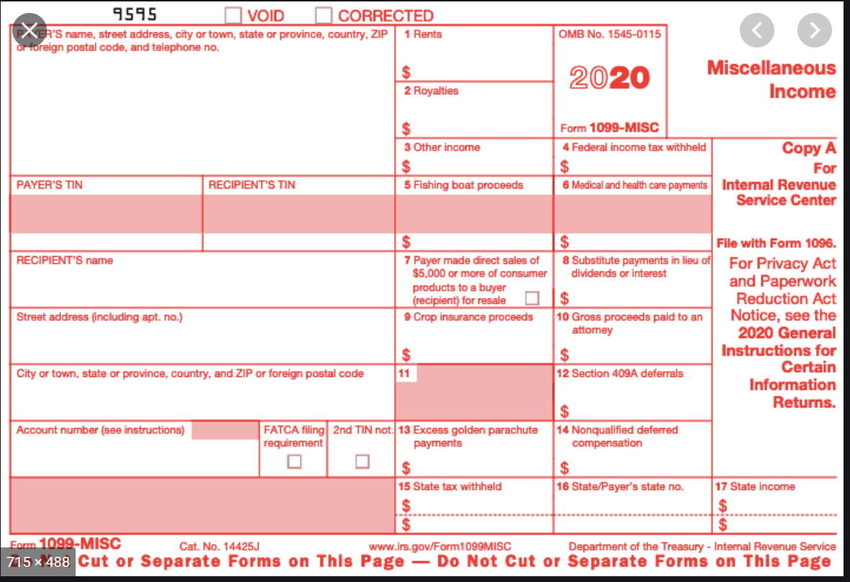

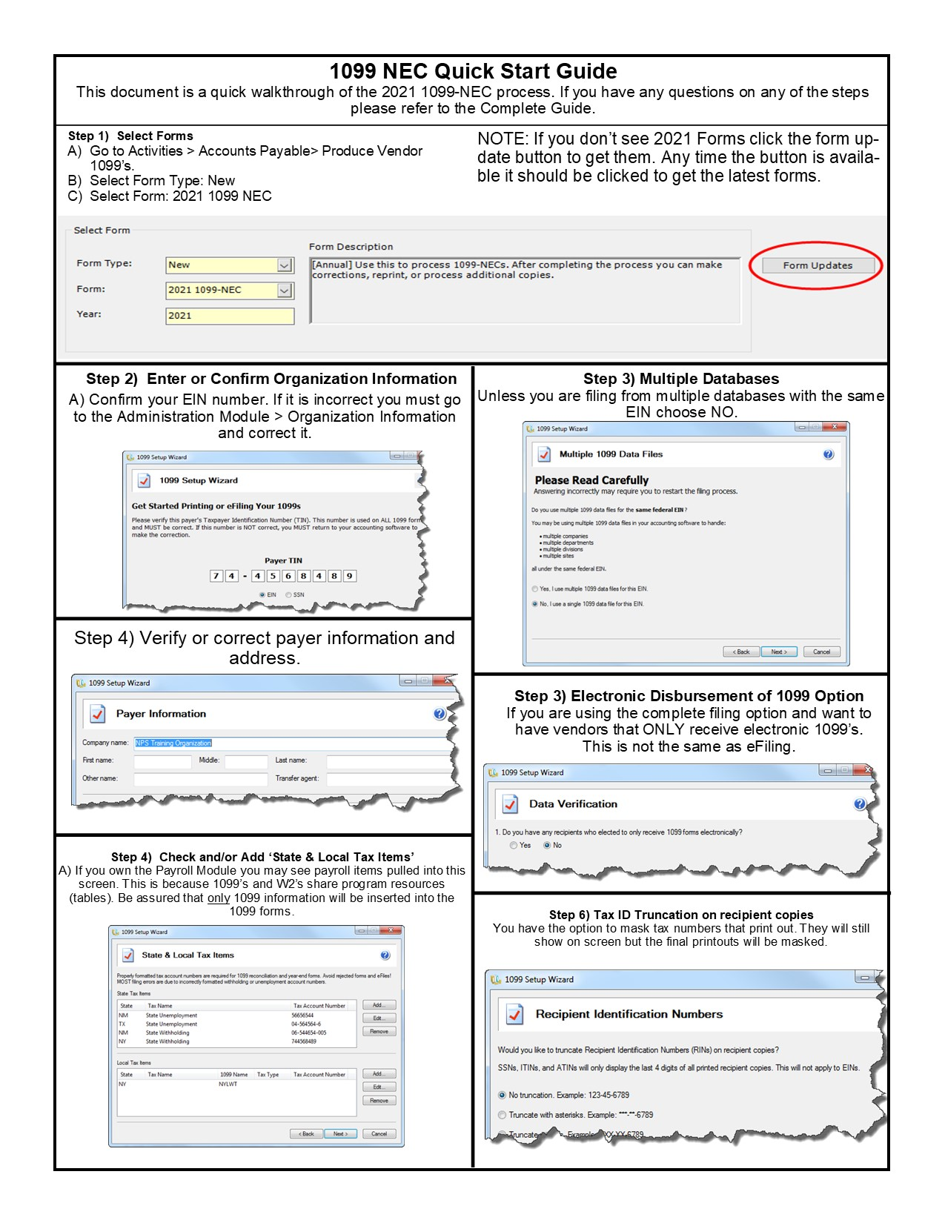

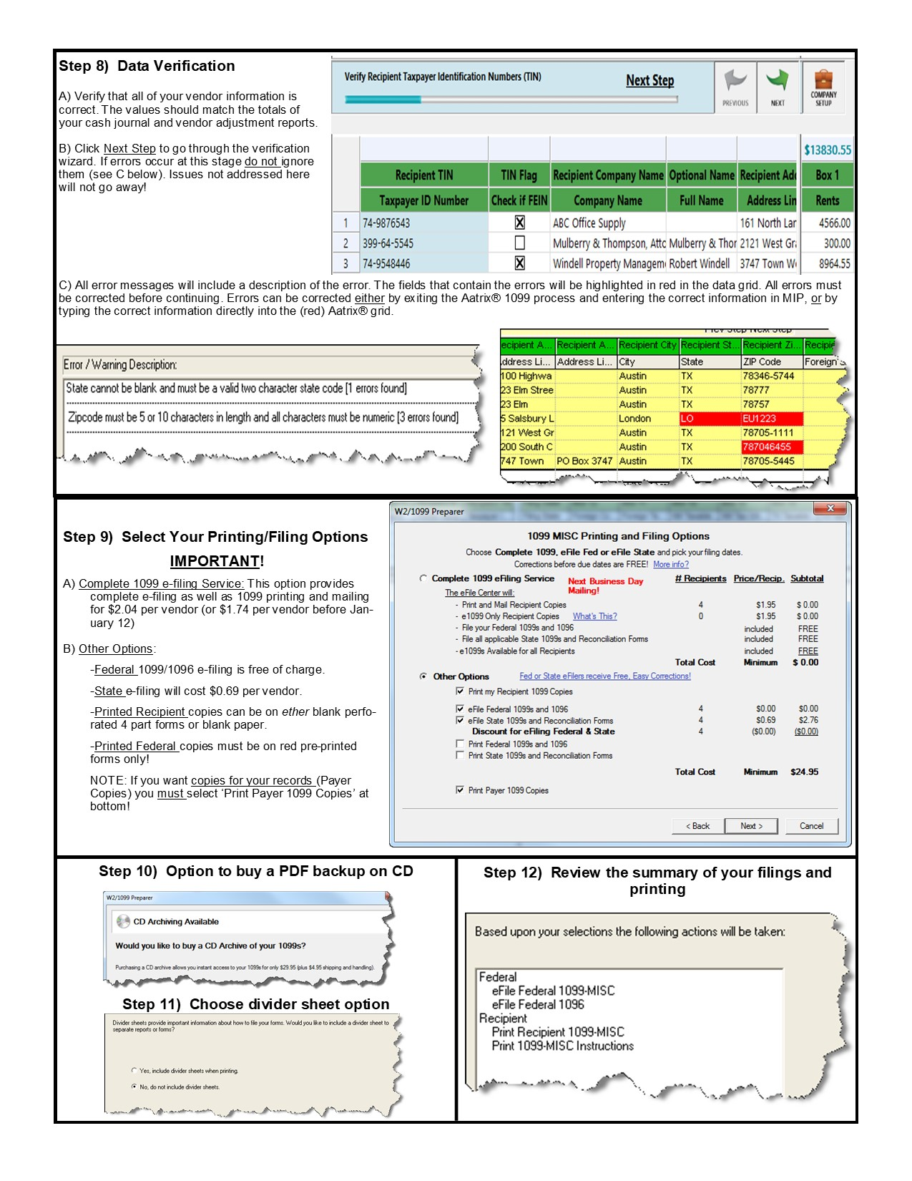

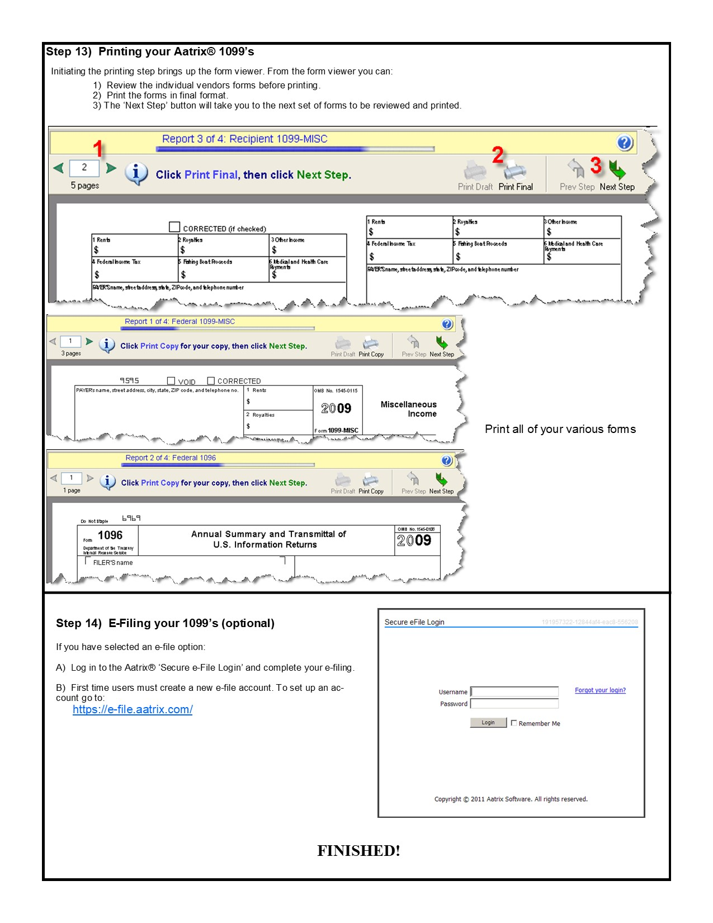

Contents

Section 1 – Producing 1099 MISC 6

Form Selection Box 6

Form Updates- 6

Aatrix Setup Wizard 8

Test Mode 8

Multiple 1099 Data Files 8

Payer Information 9

State and Local Tax Items 9

Data Verification 10

Section 2 -The Preparer Grid 12

Verifying Data 12

Making Corrections- 13

Section 3 – Sorting and Grid Functions 14

Section 4 – Printing and Filing Options 15

The Complete Filing Option (Recommended) - 15

Print Recipient 1099’s- 15

Efile Federal 1099’s- 15

Efile State 1099’s- 15

Print Federal 1099 and 1096- 16

Section 5 – The Form Viewer and Printing 17

Printing 17

Saving Electronic Copies 18

Efiling 18

Section 6 – Corrections and Reprints 20

Reprinting 1099- 21

eFile or Print Incomplete 1099s- 23

Correct Completed 1099’s- 23

Start Over- 25

Section 7 – Required 1099 forms 26

Section 8 – Auditing 1099’s 27

# Section 1 – Producing 1099 MISC

## Form Selection Box

To begin the process, go to Activities>Accounts Payable>Produce Vendor 1099’s

This will bring up the 1099 form to make your selections.

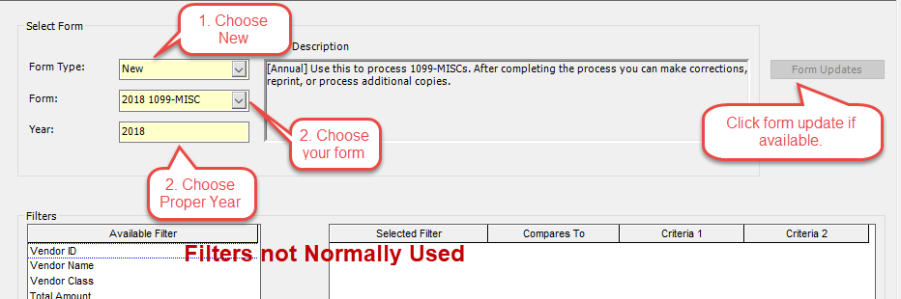

1 – Select New for the Form Type if you are processing a new filing and have not yet filed anything. If you have already filed see Section 6 – Corrections and Reprints.

2- Choose the 1099-MISC for the current year.

* If you do not see the current years 1099-MISC it is because you have not done the Form Updates. Run the form updates, get out of Aatrix and back in and you should see them.
* If you are unable to run the Aatrix updates (it is grayed out) see Form Updates below.

3- Choose the proper 1099 Year.

The filter should only be used if you are running 1099’s for different Tax ID numbers (see KB 12791). The previous exclusion of vendors paid less than $600 not longer applies to any of the remaining information on the 1099-MISC. You should not filter on a dollar amount.

Click OK at the bottom of the screen to begin the Aatrix process.

## Form Updates-

Before you can process your 1099-MISC you must download the latest form updates. These updates are normally available around December 20th.

To download the updates, click on the form Updates button. This will take you to a wizard to download the updates. You should choose the Automatic Update option and follow the wizard. If the update button is grayed out, then you have either already applied the latest update, your security settings are preventing it from accessing the update folder, or your windows account is not a local administrator on the machine.

Check to make sure your WINDOWS account (not MIP account) is a local administrator on the machine. If it is, then you will need to have your IT resource resolve the security issue (browser security settings, firewall, proxy server, blocked ports, etc.) before you can get the update. Information on this can be found in KB 1336.

<https://kb.abila.com/article/problems-and-solutions-updating-aatrix-forms>

If you are unable to get the Automatic Update to install, you can consider using the manual update. This may allow you to get the form installed, but if you need to efile you will likely have similar issues.

After clicking OK Aatrix will begin a data collection process. Depending on the size of your database and the speed of your machine, this may take some time. When it is done, you will be in the Aatrix Setup Wizard.

NOTE: Sometimes the wizard pops up BEHIND the program. If the program finishes collecting data and then appears to vanish, look on your task bar for a second MIP icon or minimize everything and look for a hidden window.

## Aatrix Setup Wizard

The Aatrix Setup Wizard will guide you through the Aatrix process.

## Test Mode

The first screen will ask if you want to run the process in Test Mode. This allows you to test the process all the way through connecting to the e-file server without having to file.

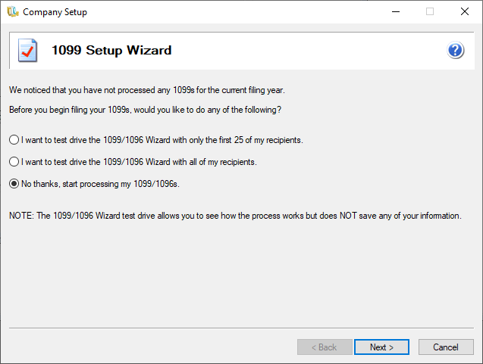

NOTE: Any changes you make in test mode will not be saved and will have to be made again. Any filings you do in this mode will not be recorded and will contain a DO NOT FILE watermark.

**Confirm the TIN**

This screen allows you to confirm you TIN Number. If you TIN Number is not correct, it cannot be fixed at this point. To correct or change your TIN number, go to Organization>Organization Information and change the Federal Tax Identification Number. Exit out of MIP and log back in again for this change to take effect.

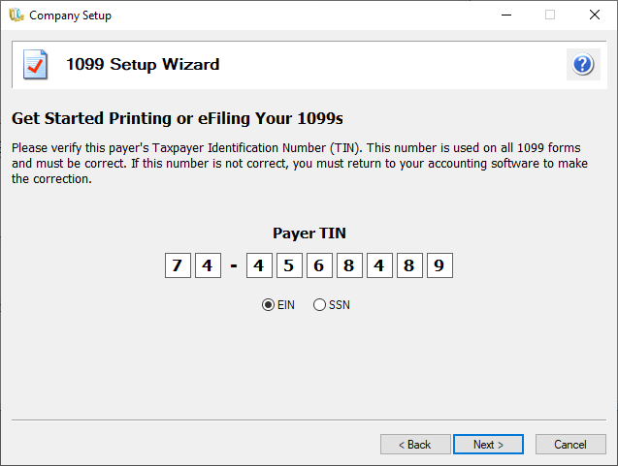

## Multiple 1099 Data Files

This allows you the option to create multiple 1099 Data files for one TIN number. Most users will select **NO** on this option. (*For detailed Instructions on filing multiple databases under one EIN see* KB 7946. *For instructions on filing for Multiple EIN’s from ONE database see* KB 12791*).*



## Payer Information

This allows you to confirm or update information about your organization as it will appear on the Tax form.

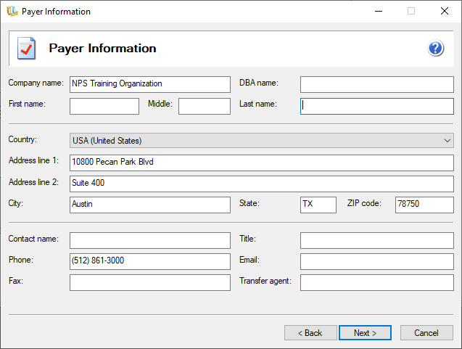

**Tax Preparer Type**

Unless you are a CPA or Tax Preparer filing for someone else, you should choose “I am filing for my company/employer”.

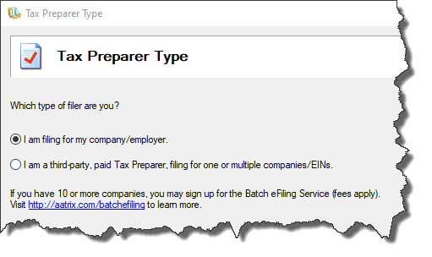

## State and Local Tax Items

This allows you to add State and Local Tax items to the 1099’s. In most cases this is not needed unless you are reporting tax withheld against vendor payments.

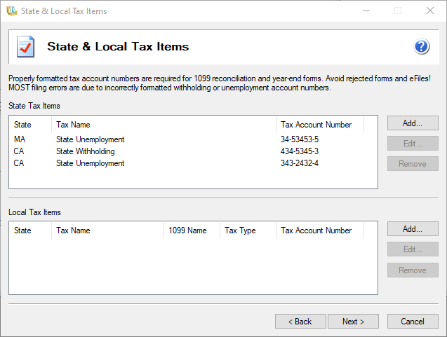

NOTE- Because MIP Fund Accounting and Payroll modules share the same database, you may see PAYROLL items in the Tax Items box. This is normal. This data will NOT be pulled into 1099 processing.

## Data Verification

Use this only if you have vendors that would like to only receive electronic copies of their 1099’s. This refers to an electronic distribution of the VENDOR’S copy of the 1099. It does not affect e-filing or submitting forms to the government.

You must choose the Complete Filing Option to have the ability to distribute electronic copies.

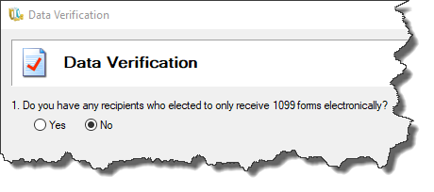

**Recipient Identification Numbers**

This will allow you to Truncate or mask the Vendors Tax ID Numbers on the printouts. This will not affect how they show up on the form viewer screen in Aatrix, only how they print.

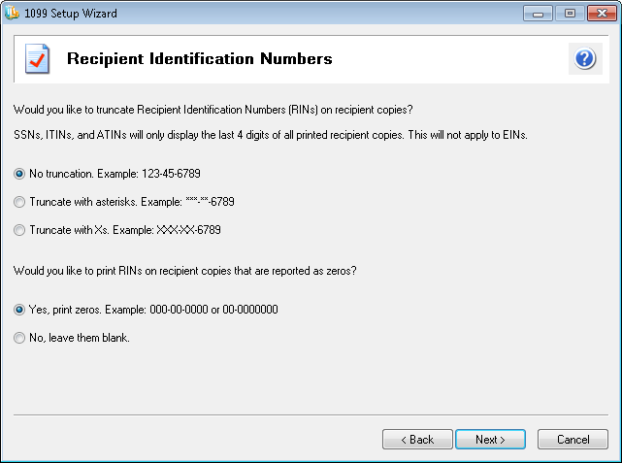

# Section 2 -The Preparer Grid

The preparer Grid allows you to review and, in some cases, make changes to the 1099 information before moving to the printing and filing.

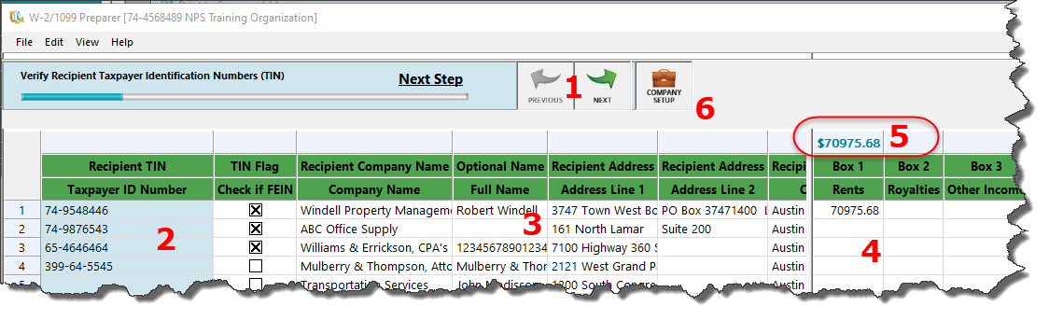

After you have loaded the grid you will need to go through several validations to assure your information has all the requirements to successfully file. You can click on “Next” or “Previous” to move forward or backward through the steps.

1 – Next Step Arrows – Click here to move onto the next step or click “Previous” to go back a step.

2 – This is the Taxpayer ID number of the Vendor. If they are a FEIN vendor, the checkbox next to it will be flagged. TIN/FIEN selection will change the requirements for the optional Full Name and how the names print on the 1099.

3- This section contains all the non-financial information on the vendor such as name, address, city, etc.

4- This section contains the financial information on the vendor, such as the amounts and what box numbers they are in.

5- This is a total of all the 1099 Amounts in that box. Useful for reconciling your amounts.

6 – Company Setup. Clicking this button will take you back through the Organization setup Wizard you went through when launching Aatrix. If you need to change any of those selections or modify information, click this button.

## Verifying Data

The purpose of the grid is to go through and verify that the information is both correct and complete. To assist with this, Aatrix has several verification steps that will check to make sure all the required information is in the grid for a successful filing (it does not check the accuracy of the info, just if it exists). As you click Next, if Aatrix finds missing or incorrectly formatted data, it will highlight it and give you the change to correct.

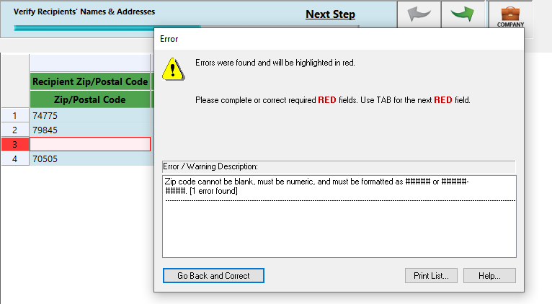

Aatrix will highlight the ROW and CELL that has a problem and give you information about the problem. You can click Go Back and Correct to address this issue

## Making Corrections-

Any changes made on the preparer grid will NOT be reflected in MIP. If you exit out and get back in, the changes will be lost. Reports that you run in MIP will not support the values on the grid.

If you need to change any information in the grid, it is recommended that you:

1 – Exit out of the Aatrix grid without saving changes

2 – Go back into MIP and make the corrections

* If you need to correct Vendor information, go to Maintain>Vendors and update the vendor information
* If you need to change the amounts in the 1099 Box go to Maintain>Vendors>1099 Information Tab. You can use the 1099 Adjustments box to increase/decrease the amount. Put in the difference between the value it had in the grid and the value it should be

3- Start the Aatrix process again. If it asks if you want to use Work in Progress, say no. This will pull the changes in.

# Section 3 – Sorting and Grid Functions

Sorting – It is possible to sort information in the Aatrix Grid. To do so Right Click on the column header. This will give you several options, including the ability to sort on that column. This can be useful if you wanted to sort records by dollar amount.

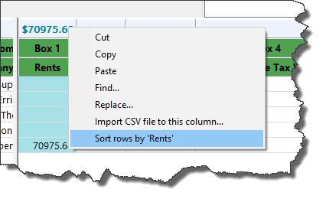

Deleting – If you want to remove records from the grid

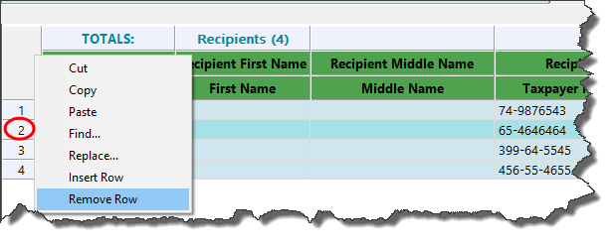

Insert Rows – If you need to add an additional Row (A vendor that is not in MIP) you can either Right click on any Row and Choose “Insert Row” or go to the Edit Menu up top and Choose the “Insert Row” option.

Find and Replace – Aatrix can do a Find or Find and Replace. To use this feature, you must first select one or more Rows or Columns. The search will be limited to that data. You can use the SHIFT + CLICK to select multiple contiguous rows. Only one column at a time may be selected. Once selected, Right click and use the Find or Replace Function. Or you can choose the options from the edit menu.

Copy/Paste – It is possible to Copy/Paste information to/from the Aatrix grid. However due to limitations of the Aatrix programming this functionality is limited to ONE row or column at a time. You cannot copy/paste multiple Rows or Columns simultaneously. If you need to copy/paste multiple Rows or Columns, you will need to do them one at a time.

# Section 4 – Printing and Filing Options

Once you have completed all the validations Aatrix will take you to the printing and Filing options.

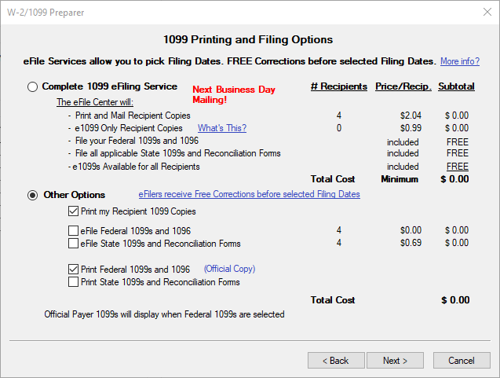

The options are:

## The Complete Filing Option (Recommended) -

This option saves a lot of time effort and, in many cases, money purchasing forms and postage. With the complete filing option Aatrix will:

-Print and mail 1099’s to the Vendors. You do not need to buy paper, envelopes, or postage.

-Electronically file Federal and State (if applicable) 1099’s.

-Make e1099’s available for all recipients.

The cost of this is $2.04 per recipient with a $24.95 minimum.

If you choose this option, you will still have the chance to print out record copies of all your forms.

## Print Recipient 1099’s-

This option allows you to manually print out and mail your Recipients 1099’s. This will require that you have compatible paper and envelopes (See Section 7 – Required 1099 forms). Recipient copies are designed to go on blank 4-part perforated paper. Pre-printed forms of any type will not work for the Recipient copies.

## Efile Federal 1099’s-

This option allows you to electronically file your Federal 1099’s. There is no charge for the FEDERAL efiling of 1099’s. It is included if you choose the complete filing option. You will still have the option to print record copies of your forms.

## Efile State 1099’s-

This option allows you to electronically file your State 1099’s if required. There is a $.69 per record charge with a $24.95 minimum. This is including if you choose the complete filing option. You will still have the option to print record copies of your forms.

NOTE: To use any of the above options you will need to set up an account with Aatrix and have a credit card number on file, even if there will be no charge. When you set up an account the first time, you must fill out an authorization form and fax it. All filings should be submitted at least 2 days prior to the deadline to guarantee on time filing.

## Print Federal 1099 and 1096-

If you do not wish to do any type of efiling and instead want to print and mail your FEDERAL copy, choose this option. For the FEDERAL copy of the 1099, it will require a form that is pre-printed in RED ink and contains two parts. No other type of form will work for the Federal Copy of the 1099. See Section 7 – Required 1099 forms.

**Print State 1099s and Reconciliation Forms-**

If you need to print and submit your STATE 1099 Copies, choose this option. This will print out your STATE 1099 Forms as well as any state specific reconciliation forms. The State forms are designed to go on Blank paper. You will still have the option to print record copies of your forms.

**Review Data –**

This screen lets you review what you plan on printing. Clicking PRINT on this screen is not necessary and will not print out your forms. You should click next.

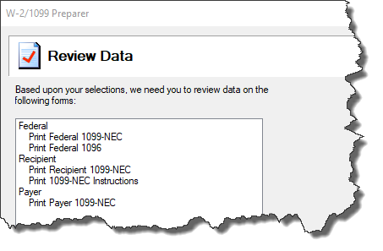

# Section 5 – The Form Viewer and Printing

This section allows you to proof the final output of your forms and see what they will look like when printed. If you have chosen an electronic filing option, you will still see your forms here and have the option to print them, but they will have a Record Copy watermark.

The form viewer has several options to be aware of

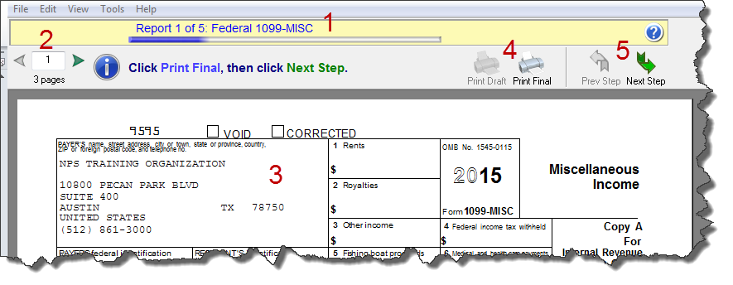

1. This tells you the form you are looking at. This allows you to clarify what form you are reviewing and are about to print.
2. Which page of the form you are looking at. If you have many recipients, you may have many pages.
3. This is the form information. Review this to make sure it is correct. If there is an error, you should exit out of the form viewer and correct it.
4. Print option – Depending on the type of form you are viewing and your filing options, you will have the option to print Draft or Print Final. If you choose print final, it will prompt you to load the appropriate type of paper for the form and record the form as having been printed.
5. Next Step – This allows you to move to the next form to review/print. After leaving a form, you cannot go back without starting over.

NOTE: To register as having been printed, all forms associated with a filing must be printed. If you print only the 1099 or 1096, Aatrix will not record the 1099 filing as having been completed and printed. If you go back to correct this filing, it will not be available to correct. You will have to re-create it and print it.

## Printing

When you choose the print button, you will have several options depending on the type of form. If this is the first time printing a form that requires perforated paper (Recipient Copies) or the Red Pre-printed stock (Federal Copies), it is a good idea to click the Page Align Button. This allows you to print alignment forms to make sure everything lines up and make any adjustments to alignment if needed. This can prevent you from wasting purchased forms.

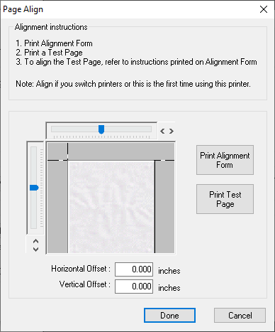

## Saving Electronic Copies

It is possible to print forms more than once before moving to the next form. To do so simply click the Print Button again. It is HIGHLY recommended that you print a copy of your forms to an electronic format (PDF or XPS) and save it for your records.

To do this, click the Print Button. Down in the “Printer” Section choose either a PDF or XPS document writer, then click ok. Aatrix will prompt you for the location and name of the file you wish to save. This can be very useful if someone asks for an extra copy of the form.

After you are done printing all copies of a form click NEXT and move on to the next form.

## Efiling

Even if you have selected the Complete Filing option or only an efiling option, you will still have an opportunity to print your forms as record copies. After you have gone through that process, you will be prompted to log into the Aatrix Efile server to transmit your information.

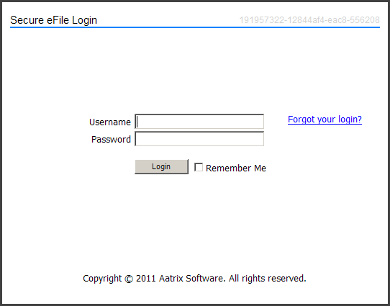

To use the eFiling, you need to have set up an account with Aatrix and have faxed in an authorization letter. Your account number is usually your organizations Tax ID number. If you have forgotten your password, you can click on the link on the screen. If you do not know your username, your password, or have any questions about your Aatrix account (or questions on your filing status) contact Aatrix Support at:

701-746-6814 or email at [helpme@aatrix.com](mailto:helpme@aatrix.com)

Abila Support cannot answer any questions about your Aatrix account or filings.

Once you have submitted your efiling you can log into the Aatrix efile website and check your filing status.

<https://efile.aatrix.com/>

You should receive messages there as well as email notifications about your filing status. Each filing will have a unique number called the AFID associated with it. If you are making inquiries to Aatrix about a filing, having the AFID ready will speed things up.

NOTE: For 1099’s that have been submitted with the complete filing option or efiled, it is normal for Aatrix to hold that filing until the last week of January. This is to allow you make any corrections without incurring additional filing fees.

# Section 6 – Corrections and Reprints

After you have completed an Aatrix filing you may need to go back in and make corrections or reprints. The best way to do this is to go back into Activities>Accounts Payable>Produce Vendor 1099’s. Choose the History Option and then look to the bottom of the page and click OK.

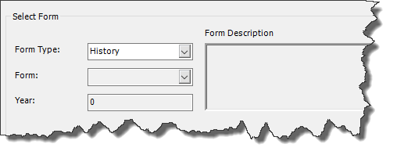



This will bring up the History Option Window. This will show all saved filings. If you do not see your filing here, it is because it was not recorded as saved and it will have to be redone.

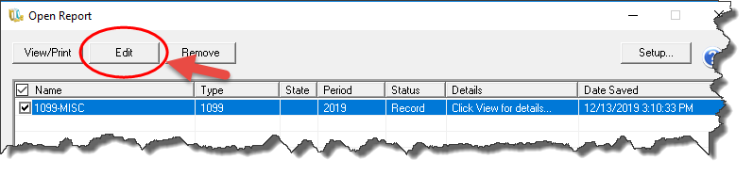

Select the filing you wish to use and click Edit. Clicking View/Print only prints the listing, not the filing.

This will bring up the History File Options. From these windows you can do several things:

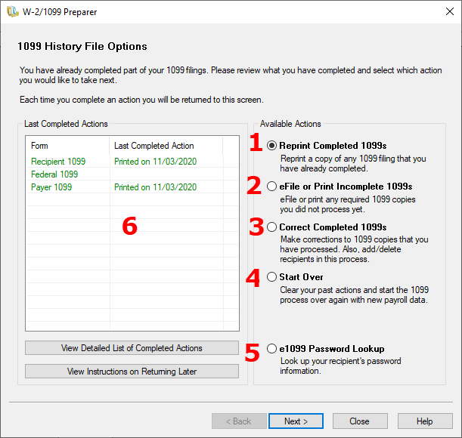

1. Reprint Completed 1099’s.

If you need to reprint anything from a 1099 Filing, this is the option you would choose. This applies if you want to print one record or the entire filing. You can only Reprint items from a completed filing. If you look to the window on the left, you can see what filings have been completed.

1. eFile or Print Complete 1099’s.

You can use this option to process any filings that remain. For example, if you have printed the Recipient but not the Federal Copies, you would choose this option to print the federal copies. If you have printed a filing but then decide you want to do an eFiling instead, this is the option you would use.

1. Correct Completed 1099’s.

If you need to change the value of a record, add, or remove a record or update your company information, you will use this option. This option will take you to the Aatrix grid and allow you to make your corrections there. After you have made your corrections, you will go to print and filing. The system will determine if the corrections will be marked as a replacement or corrected filing based on the filings that have already happened.

1. Start Over

If you want to discard the existing data and pull fresh information in from MIP, use this option. If you have successfully transmitted your efiling or indicate that you have already sent out your federal filing, this option will not be available. You would need to use Correct Completed instead.

1. e1099 Password Lookup

This only applies if you have chosen the complete filing option. It allows you to look up access passwords for your recipients.

1. Last Completed Actions

This is a list of all the possible filings and their last status. If you have printed/filed a form but it does not show on this list, it means that Aatrix has not recorded that filing. You will not be able to edit or correct the filing, instead you would use the “eFile or Print Incomplete 1099’s” to complete that filing. There is no other way to recover or add that filing.

## Reprinting 1099-

Choose this option to reprint some or all of your filing. Depending on what type of filing it is, you will have different options.

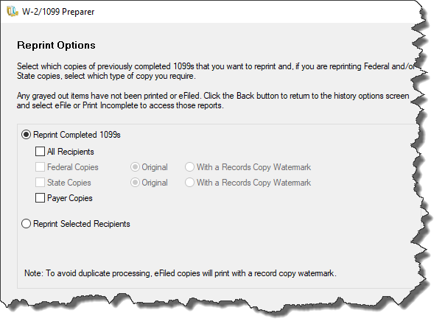

Click Next and Aatrix will load the form Viewer to Review and Print.

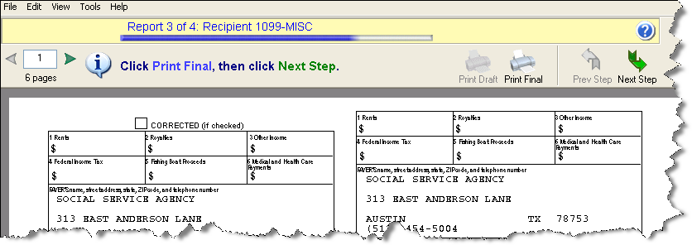

If you selected to Reprint Selected Recipients, there will be a Reprint Options screen that lets you filter or choose specific records.

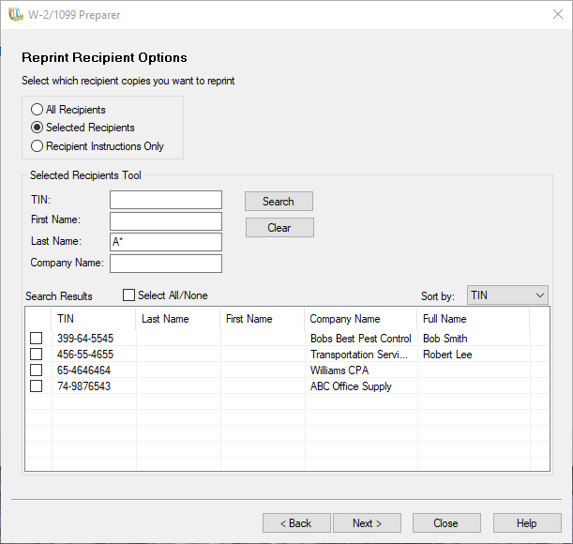

If you reprint Federal or State copies, you will have the option to reprint an original or print a record copy with a watermark. If you have efiled, it will automatically print the record copy with the watermark to prevent duplicate filing.

## eFile or Print Incomplete 1099s-

Choose this option to either complete a filing that has not been completed or to efile a filing that has only been printed. Choosing this option will take you back to the 1099 Printing and Filing Options. Here you can choose the type of Filing that you wish to complete and go through the process.

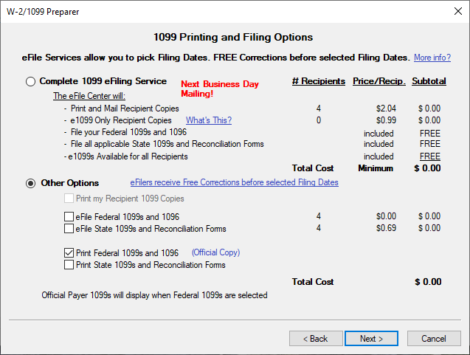

This will take you to the form viewer and allow you to complete printing and filing. Once you are done, it will take you back to the history window and show the updated status after it is complete.

## Correct Completed 1099’s-

Choose this option if you need to update, add, or remove a record or change anything in the company information. Depending on what you have completed you may be asked if you have distributed any copies yet.

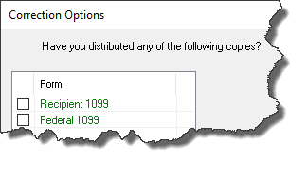

You should answer the question based on what you have done. If you have mailed or distributed a filing, check the box. If you have not, then do not check it. If you have distributed the filing, then the system will treat the corrections as a Corrected form and will check the corrected box. If not, then the system will treat it as a replacement form of the original.

If you have completed and submitted an efiling, the system will know that and may not give you the option.

The next step will take you to the Aatrix Corrections Grid. Make any corrections to the data as needed. If you make a change to a field Aatrix will highlight that row as well as change the field to a different color to let you know that you have made a correction.

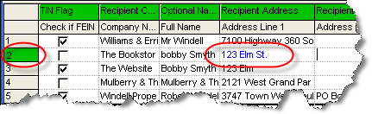

NOTE: Corrections made here will NOT flow back into MIP. MIP should also be updated with any corrections that you make in the Aatrix grid.

NOTE: DO NOT delete any records from this grid unless the vendor was included in error. Deleting records will cause a correction for that vendor to be issued. If a vendor was issued a 1099 by mistake, then select the row and right click and choose delete row. This will not delete the row, but it will zero out amounts.

If you have a vendor that should have been included but was not, then you can right click or go to the Edit Menu and choose Insert Row. Then type all the information in for the vendor. At this point, there is no way to pull the information in fresh from MIP. It must be manually added.

If you need to make a correction to your company information, then click on the Company Setup button.

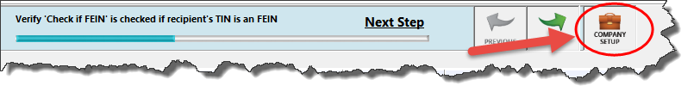

This will take you back through the Company Setup Wizard and allow you to make changes.

After you have made changes and corrections, they system will take you to the Forms Viewer where you can view and print your corrected forms. The system will choose which forms to print and file based on what you have previously efiled, printed or told it that you have disbursed. This option will also control if the printout is a replacement or if it is tagged as a correction.

In addition to the official printout, it is highly recommended that you print a electronic copy to PDF or XPS.

NOTE: When you do a correction and then re-submit your efile, it will REPLACE the existing efiling. All additional efilings will replace, not add to or subject from, the data that is submitted. Therefore, it is important to not delete records unless they are included in error.

## Start Over-

If you have not disbursed any filings (efiled or mailed them out or given them to vendors) and you wish to pull the information in fresh from MIP, then you can choose the start over option. If you choose this option, you will be asked if you have distributed any copies. If you have, then you should use the correct completed option instead.

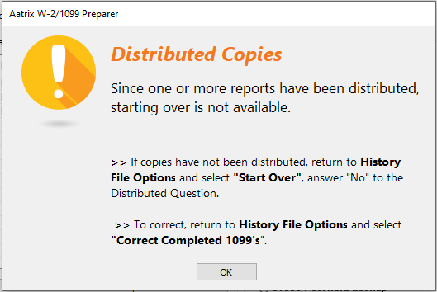

If you do start over, it will go through the data collection process again. Anything that you have entered in the Aatrix grid will be lost.

NOTE: If you have submitted an eFiling, Aatrix will know that and Start Over will be Disabled. You must use Correct Completed instead.

# Section 7 – Required 1099 forms

**1099 Form Requirements**

-The Federal copy of the 1099 forms (all) must be printed on a red pre-printed form with black ink.

-The Federal copy of the 1096 must be printed on a red pre-printed form with black ink.

-The Recipient Copy of the 1099 (all) should be printed on the blank 4-part perforated paper.

-The Payer Copy of the 1099 forms (all) may be printed on plain copier paper, no forms needed.

Below is a pricing list, including the form numbers for MIP Checks and Forms.

To order call 1-844-857-2898 or log on to:  
   
<https://www.mipchecks.com/estore/TAX-FORMS/1099s-and-1096s/cat1820040_ctgy.c?networkId=Abila>

Only these part numbers are compatible with MIP Fund Accounting

Below is a pricing list including the form numbers for MIP Checks and Forms.

To order call 1-844-857-2898 or log on to:  
 <https://www.mipchecks.com/estore/TAX-FORMS/1099s-and-1096s/cat1820040_ctgy.c?networkId=Abila>

Only these part numbers are compatible with MIP Fund Accounting

**1099 Forms**

**1099 Laser Federal Copy A (pre-printed) – Two vendors per page**

L99A (MISC) One Part

L99IA (INT) One Part

L99DA (DIV) One Part

L99RA (R) One Part

**1099 Laser Blank 4-up (Vendor Copy B, C and State) – One vendor per page**

L99BLANK4 One Part

**Bundle 1099 Laser Package Set with Envelopes**

L99BK4DWS One Part

1099 Forms have the following features

• MISC, DIV, INT, and R

• Fully compliant with IRS Publication 1179

• For use with Laser or Inkjet printers

• One free 1096 Transmittal form with every 1099 order

• Compatible regular or self-seal envelopes available

**Question**

If I have forms left over from last year, can I use them?

**Answer**

The blank perforated stock does not change from year to year. Any unused blank stock from last year can be used this year. The pre-printed Federal Copy has the year marked on it and cannot be reused.

# Section 8 – Auditing 1099’s

It is a good idea to run a report to audit your 1099 amounts before submitting them. In MIP, the best way to do this is to set up and run a Cash Journal Report.

Go to Reports>Journals>Cash Journal> <1099 Detailed Vendor Total Report>

Change the dates to be the proper year.

Go to the Content Tab and Add the 1099 Adjustment Amount in the Selected Columns so you can view adjustments made in Maintain>Vendors>1099 Information>1099 Adjustments Tab.

Remove the Adjustments columns in the report body.

The report setup should look like this-

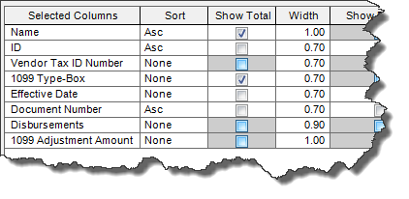

The output will look something like this

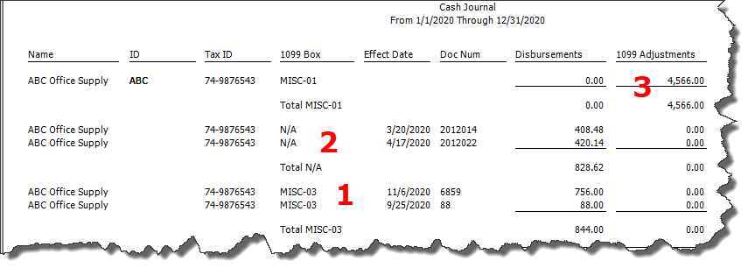

Notice that this report shows activity that is coded to the a 1099-Box (1). It shows any amounts coded that did not have a 1099 Box associated with them (2). It shows any 1099 Adjustments you have made under Vendor Information (3). With this information you can find out where your 1099 Totals are coming from and correct them if needed.

The best way to fix any incorrect amount is to go to Maintain>Vendors>1099 Information tab, and there is a 1099 Adjustments form at the bottom of the page. You can do an adjustment to add or subject amounts from the 1099 Total. You would want to adjust by the amount of the difference between what the total currently is and the desired total. For example, if the total is $1000 and it should be $1300, you would do a +$300 adjustment.

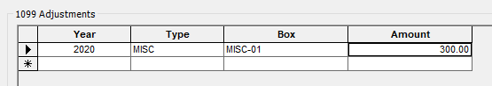

If you have an adjustment that is done improperly, you can just select the row and delete it.

**Question**  
I have a 1099 vendor and I have run a cash journal and the total for the vendor is ok, but the amounts in the 1099 boxes are not. Why is that?  
   
**Answer**  
The most common cause of incorrect amount in a 1099 box number is because the vendor was not properly set up or the information not properly entered at the time of posting.  
   
In order for a transaction to affect the value in a 1099 box, it must meet the following three conditions:  
   
1)    It must be coded to a CASH type GL account  
2)    It must be coded to a vendor that at the time of entry was flagged as a 1099 vendor.  
3)    In the data entry screen, it must have a 1099 type associated with it and it must be coded to a 1099 box.  
   
Many times a vendor will be initially set up and not all of the 1099 information will be available. Checks will be cut to this vendor and then later the 1099 information will be entered. The checks cut before the data was complete will not show in the 1099 box amounts; The checks cut afterward will.  
   
**Question**

What should I do about my MISC-07 amounts showing up when I run the report for 2020?

**Answer**

If you are running the cash journal report for 2020 and you have amounts showing up in the MIS-07 Box, look to see what column they are in. If you see them in the Disbursements column, it means that you have not upgraded to at least 20.3. After the 20.3 Upgrade there should not be any values in the MISC-07 Disbursements for 2020. Values before 2020 will remain.

If you have MISC-07 values in the Adjustments Box, those came from manual adjustments made to the vendor. These values are not valid in MISC-07 in 2020, and as a result Aatrix will ignore them. You can delete them from the Vendor Adjustments if you want, but it is not required.

FAQ-

*Q: I don’t see my 1099 forms in the dropdown.*

A: You have to apply the form update (page 7).

*Q: I have the 2021 forms but Aatrix says I’m on an expired version.*

A: You should update MIP to 2021.1 in order to run your 1099’s.

*Q: How do I print the recipient copy on the two part pre-printed forms I bought?*

A: You can’t. Only the 4 part blank forms will work (page 26).

*Q: I tried to do the form update but it failed. How do I get the forms?*

A: Issues with the form update as usually because you’re not a local admin in windows or because of internet security settings. See KB 1336. You can always download and install the manual update.

*Q: My 1099 Amounts are too low, how come?*

A: Most likely one or more vendors were not tagged as a 1099 vendor when they were set up. You can run a report to audit (page 27).

*Q: When I go to Correct Completed it doesn’t show a filing I did as having been completed. How do I fix that?*

A: Unless it was a successful efiling you cannot recover a filing that did not get saved. If you successfully efiled you can give Aatrix a call at 701-746-6814 to see if they can assist.